Chapter 2 Elementary Programming

1.

area is 11.0

miles = 100
kilometers = 1.609 * miles
print(kilometers)

The value of kilometers is 160.9.

value = eval(input("Enter a numeric value: "))

It will cause an error. You have to enter a numeric value.

To break a long line, place the line continuation symbol (\) at the end of a line to tell the interpreter that the statement is continued on the next line.

Valid identifiers: miles, Test, apps, x, y, radius

Invalid identifiers: a+b, b–a, 4#R, $4, #44,
if, elif

Keywords:
if, elif

- Use lowercase for variables. If a name consists of several words, concatenate them into one, making the first word lowercase and capitalizing the first letter of each subsequent word—for example, the variables radius, area, and numberOfStudents.
- You should write a = 2
- x, y, and z become 0
- a becomes 2 and b becomes 1
11.

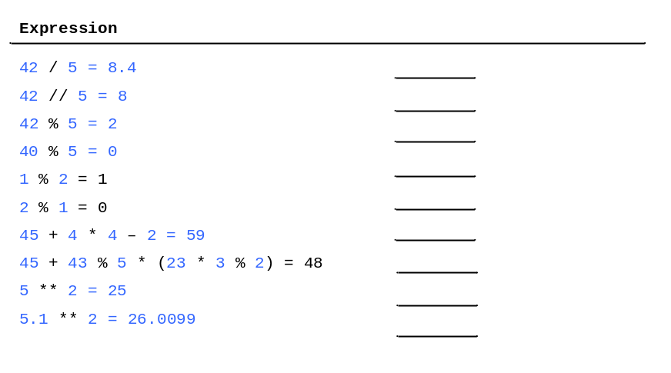

12.

(2 + 100) % 7 = 4. So it is Thursday.

13. 25/4= 6.25 If you want the quotient to be an integer, use 25 // 4.

14.

4.0 / (3.0 * (r + 34)) – 9 * (a + b * c) + (3.0 + d * (2 + a)) / (a + b * d)

15. m * r * r or m * r ** 2
16.

a += 4 (a is 5)
a -= 4 (a is -3)
a *= 4 (a is 4)
a /= 4 (a is 0.25)
a //= 4 (a is 0)
a %= 4 (a is 1)
a = 56 * a + 6 (a is 62)

17. The fractional part is truncated. Calling int(value) does not change variable value.

18.

print(int(value)) 4
print(round(value)) 5
print(eval("4 * 5 + 2")) 22
print(int("04")) 4
print(int("4.5")) causes an error
print(eval("04")) causes an error

19. The UNIX epoch is the time 00:00:00 on January 1, 1970 GMT.
20. time.time() returns the seconds with millisecond precision since the UNIX epoch.
21. To obtain seconds from the return value of time.time(), use int(time.time()).

